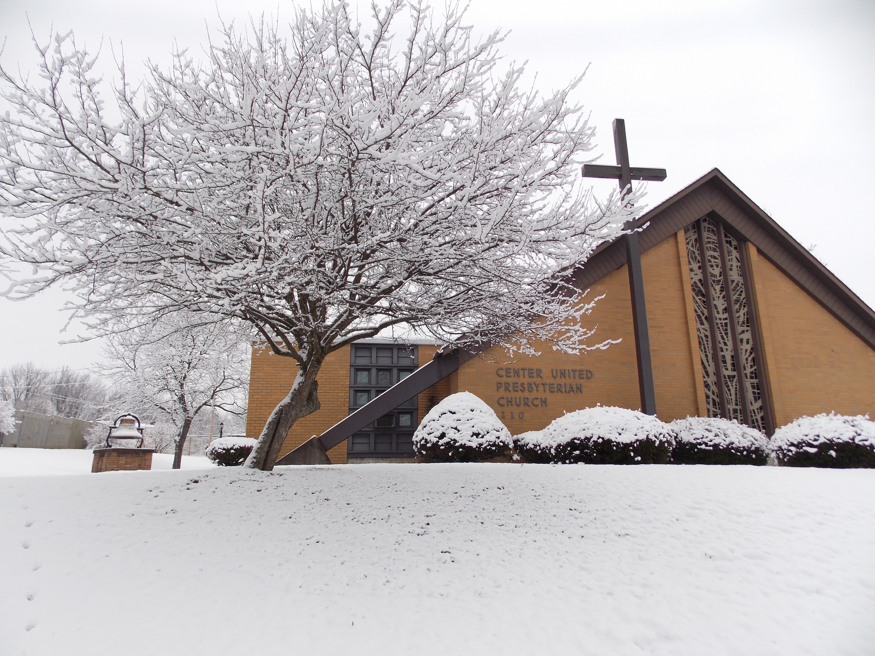
Center U.P. Church Newsletter – January/February 2017
Office Hours ~ Mon: 9am-noon; Tue: 9am-noon; Thur: 9am-noon Phone: 724-796-3351 email: centermidway@rocketmail.com Mobile Phone: 724-678-6976 website: www.centermidway.com

Salutations from the Pastor

Okay, as I write this it’s still technically Christmas (and will be until Jan. 6th), so I want to share something I was considering as a sermon topic, because I’m just not ready to let Christmas go yet. It’s tied to Christmas trees and I bet many of us still have our trees up anyway. In mid-December I considered whether to include “O Christmas Tree” as one of our Candlelight Service carols. I decided against it because neither God nor any biblical theme is mentioned until the last verse (and then only generally). I know many “die-hard” Christians who would object with the rationale: “The song focuses on a pagan celebration symbol.” In the past, I have shared similar sentiments in the effort to keep our observance of Christmas firmly centered on the gift of God taking on flesh in Jesus. But perhaps we can redeem this symbolism, as Christians have long done historically. The first German Christians – from whom we get the tradition of the Christmas tree – preached the gospel of Jesus in light of their myths, showing how they point to Jesus. Here’s a case in point: in their pre-Christian Norse religion, trees are sacred because they are “mini-manifestations” of the great world tree known as Yggdrasil – which stood in the middle of the universe, binding the heavens and the earth into one cosmos – its branches and roots supporting all things in creation.
Stay with me, here comes the interesting part … the name (Ygdrassil) means, “The awesome one’s mount/horse.” Why is that important? Because it’s a direct reference to their god, Odin, who climbed onto the tree (entered the natural order) and pierced himself with one of its spears to offer himself as a sacrifice to himself, for the benefit of all mankind! Umm … do you see where this is going? The good news of Christmas is not just hidden there, it’s like the shining star on top of our church tree with the cross behind it – God giving himself to us (entering the natural order of creation) and God providing himself as the sacrifice needed to atone (clear away) our sins. This (propitiation) is exactly what three (3) different New Testament authors say God did in Jesus (Romans 3:24-25; Heb. 2:17 and 1 John 4:9-10). Want to hear more? See the devotional at the end of the newsletter. ~ Pastor Brian

Events
January 7th – “Raiding of the Greens” (4:00 pm). Join the Mariners Saturday to help take down the tree and decorations – we need lots of help. We’ll have several different kinds of soup after as our meal and would love to have you with us.

January 8th – New Year’s Communion (11 am) Join us on Baptism of the Lord’s Sunday as we celebrate the Sacrament as well as the service of Ordination & Installation of Church Officers.

January 16th – Officers Meeting (7:00 pm)

January 18th – Report Deadline for Annual CUP (typed & handwritten report deadline)

January 22nd – Submission Deadline for qualified reports (electronic only) for the 2016 CUP report.

February 5th – Annual Congregational Meeting (after worship) – please mark your calendars and attend. Souper Bowl of Caring collection.

Birthdays

1/22 Edward Lamb Jr. 2/07 Evan Bayer 1/24 Logan Bayer 2/08 Amelia Whitaker 1/25 Jesse McKean 2/10 Bill Phillis
1/26 Aaron Baird 2/17 Bailey Lyle 1/28 Danielle Rusnic 3/01 Tim Lyle II 1/29 Marion McKean 3/02 John Phillis 2/05 Linda Bozic 3/02 Jan Demnyan 2/05 Wiebke Kilbert

Fellowship of the Skein

The F.O.S. meets the 3rd Saturday of every month from 8:30-10:30 am in the fellowship hall. We enjoy a time of chatting and yarn craft of all kinds. We have crocheters, knitters and hook rug crafts going on. There is a wealth of knowledge, experience and encouragement to be shared. All levels are welcome and all types of yarn crafts. Please join us for this fun group and remember to BYOY, Bring your own Yarn! If you have questions please talk to Wiebke (724-799-3323).
1/21/17: Darla Romano hosting
2/18/17 Barb Hopper hosting
Hymn History ~ What Child is This
The text for the carol, What Child is This, was written by William Dix (1837-1898) an insurance salesman in Glasgow, Scotland. The song asks the question that must have been uppermost in the minds of those present at Jesus’ birth. How difficult it must have been for the shepherds as they gazed into that humble manger to understand that the babe who lay in ‘such mean estate’ was truly the promised Messiah. Dix’s thoughtful text came to him during a time when he was seriously ill and confined to bed for an extended period. After suffering a deep depression and calling out to God he experienced a time of artistic growth and was able to write this delightful carol in 1865. The text was originally part of a longer Christmas poem, “The Manger Throne.” We find the triumphant answer to the question in the refrain: “This, this is Christ the King.” The melody for the song is Green Sleeves, a traditional English folk tune. 1) What Child is this who, laid to rest On Mary’s lap is sleeping? Whom angels greet with anthems sweet, While shepherds watch are keeping? Refrain: This, this is Christ the King Whom shepherds guard and angels sing; Haste, haste, to bring Him laud, The Babe, the Son of Mary. 2) Why lies He in such mean estate, Where ox and ass are feeding? Good Christians, fear, for sinners here The silent Word is pleading. Refrain 3) So bring Him incense, gold and myrrh, Come peasant, king to own Him; The King of kings salvation brings, Let loving hearts enthrone Him. When they had seen Him, they spread the word concerning what had been told them about this child. (Luke 2:17)

Loads of Love
If you’ve been a financial supporter of Loads of Love you may have noticed our change jar has been removed. Currently the LOL financial balance is $188. That is 5 to 6 months worth of funds for this ministry! Our volunteer balance is currently 3 people. We need more volunteers to be able to keep this ministry in our community.
Currently, volunteers are going to the McDonald Laundromat on the 3rd Friday of the month in the morning. This time is completely flexible based on when the volunteers can go. If you can strike up a conversation with anyone you meet at the store this ministry is perfect for you. Volunteers go to the laundromat, strike up a conversation with community members, and offer to pay for their loads of laundry. The conversation is focused on how that community member is doing that day and if there is anything our church can do for them. If this sounds like something you would like to do but Friday morning doesn't work for you let Wiebke know. This program is totally flexible based on when volunteers can meet at the laundromat. We like to keep this as a team of two so it is safe for our volunteers and is also not overwhelming for the community members there. The sign-up sheet in the foyer has been changed to a date free sheet. If you’re interested in joining this ministry please sign up and include what day and time works best for you. If we can’t get three new volunteers, we will be "folding it up" so to speak and donating the balance to the McDonald Area Ministerial Association so they can spread the funds into the community, fulfilling the intent of the original donation. Thank you.

Mariners
On Sat. January 7th we will gather at 4:00 pm to “undecorate” the church. Everyone is welcome to help. But please let us know as a soup dinner will be served. Call Dan Hillberry at 724-796-0505.

Operation Christmas Child
We collected 29 shoe boxes for Operation Christmas Child. Please continue to pray for the children who will be receiving the gifts in the following month.

Per Capita
Center U.P. Church continues to withhold the General Assembly apportionment and pay only the Presbytery amounts – the 2016 per capita has increased to $27.50 per member in your family (for ex: 3 members in household would be $82.50). If you would like to pay the General Assembly ($7.50) apportionment, please submit a separate check to Betty Lou Lamb for either. Thank you.
Session
The Evangelism Committee has been trying to get ideas for reaching out to the community. As our church family has been blessed with new members, we know there are others looking for a church home. Please pray and feel free to suggest new ideas and offer help toward such ideas. Thank you. – Nancy Hillberry
Sunday School
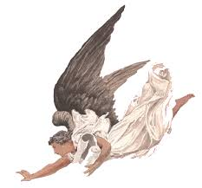
The Adult Class (traditional study) is now using the David C. Cook Bible-In-Life curriculum. Join us (Sunday mornings 9:45 am) in the Fellowship Hall.

+ Symbols of our Faith + Angel
Angel means “messenger” in both Hebrew and Greek, and is a spirit-being God created to perform tasks for Him. In the Bible, angels appear in human form (always as men) to deliver divine messages. Angels appear separately to Joseph and Mary, announcing Jesus’ upcoming birth, and “a multitude of the heavenly host” (Luke 2:13) tell shepherds of the Savior’s arrival. Scripture offers little information about angels, though we know some rebelled against God. Among the holy angels, categories include cherubim and seraphim.

Treasurer’s Report (November)
Beginning Checking Acct. $10,736.02 Envelopes $ 8,620.00 *Other Receipts (cash, etc. ) $ 181.21 Expenses -$ 8,104.41 Ending Balance in Acct. $11,432.82

Youth Group We are considering participating in the 30 Hour Famine with the youth of Hickory United EPC in March. We continue to meet on Sundays from 6:00-7:45 pm. All students ages 11-18 are welcome to join us in the church Fellowship Hall – invite some friends and let’s make our group even better this year!

A Devotional for You – Read Isaiah 26:20, Romans 3:23-26, and 1 John 4:9-10)
[I encourage you to read the Salutation section at the beginning of the newsletter first so you can fully appreciate the following devotional]. Earlier we heard about Odin’s sacrifice of himself on a tree, and it doesn’t take a rocket scientist to see in that a shadow of Jesus. But there are other reasons the Christmas tree is useful for meditation. In German lore, Yggdrassil (the world tree) was not only a place of sacrifice, it was a place of communion, for it connected the realms of heaven and earth together. So, if you wanted to commune with the divine, you did it through a tree. [I’m a sucker for symbolism, what can I say?] Did you know that the Grimm brothers (authors of all those German fairy tales) were staunch Christians, and that in their version of the story Cinderella, the tree over the grave of Cinderella’s mother is an intentional illustration of the fellowship Christians continue to have with those who die in the faith, through the tree of the cross? Though the nature symbolism gets a little confusing to me, their intent is not far from the Reformed (i.e., Presbyterian) understanding of how the Lord’s Supper spiritually unites us with the rest of the church in heaven and on earth – because of Christ’s body and blood on the cross. So, for the original German Christians, the base of a tree was still sacred, but not because pagan gods came to have assembly with mortals - as they once believed. Rather, because on a tree Jesus made communion with God possible once more. This is where the German tradition of placing the crèche (or nativity scene) at the base of a Christmas tree came from – which you will also find at the base of the Christmas tree in the chancel of our sanctuary. Both in the manger, and through the cross, that is where God came down from heaven to be with us.
One last connection to the Christmas tree. Most people don’t realize that originally, the focus of Christmas was Judgment Day – Christ’s coming in humility, as a baby, being used to reassure people that He will come again in glory at the End. Some may find such a focus frightening, but not Christians. Why not? Because there is sanctuary in the tree. You see, for the Germans the most important function of Yggdrasil was to provide a place of refuge for the last boy and girl on earth at “Ragnarok” (Judgment Day). On that day, the great serpent who gnaws at the roots of Yggdrasil would break free from his confinement (compare with Revelation 20:2, and verses 7ff.). One of the servants in the heavenly realm would sound his horn; the sun and moon would be devoured; stars would fall from the sky; and mighty Thor (son of the All-Father sent to Earth to be its guardian) would crush the serpent’s head with his hammer (please compare to Genesis 3:15 and Revelation 19:11-15), but would die in the process from the serpent’s venom. Then fire would consume the earth, but not all of it, for on that day Yggdrasil’s trunk would open up to let humanity in – it would literally become a “tree of life.” Nourished there, the new humanity would emerge to a new earth from the sea, eternally green.
It is a picture reminiscent of the story of Noah, in which the believing remnant of humankind is sealed in the “resinous tree” of the ark to be protected from the End times fury of the ancient world, until the new earth emerged from the waters (a forerunner of our other sacrament – Baptism). This is why the ancient Germans buried their loved ones in a hallowed out tree trunk (origin of our casket/“pine box”) – it was their way of showing that their loved one would be “safe in the tree” until the new world emerged … In the cross of Christ, we have such sanctuary, not just in sentiment but in reality, as the baptismal hymn sings: “Winter comes as winter must; We breathe our last, return to dust; Still held in Christ, our souls take wing; And trust the promise of the Spring.”
Never mind all the hubbub about having a tree in the sanctuary. The greater truth is that we have sanctuary in the tree – that is, the cross! On it, our sins are forgiven; through it, we have fellowship with God and our loved ones in glory; and in it, we are protected by the fury of God’s Judgment at the Last. So keep your tree up, at least until we share the sacrament of Communion on January 8th. For with its steadfast, evergreen branches, the Christmas tree proclaims the reality of everlasting life in the cross of Christ – giving hope, strength and comfort to all who seek refuge under its branches. God bless you.
~ Pastor Brian

