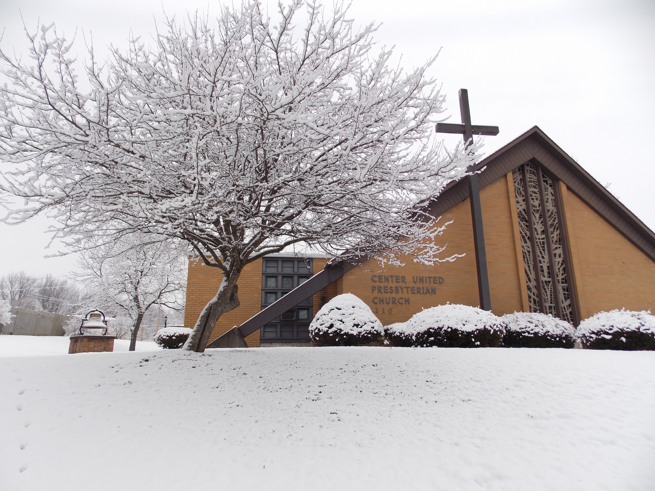
Center U.P. Church Newsletter – January/February 2016
Office Hours ~ Mon: 9am-noon; Tue: 9am-noon; Thur: 9am-noon Phone: 724-796-3351 email: centermidway@rocketmail.com Mobile Phone: 724-678-6976 website: www.centermidway.com
Salutations from the Pastor
Well, my friends, the Christmas season is wrapping up (no pun intended, honestly), but I ask you to keep hold of the Christmas message and that spirit (the spirit of Christ) in the weeks ahead as the weather gets colder and new challenges arise for us to face in the new year. We need not be afraid; indeed we can be encouraged, even excited, about what the future may bring, if, of course, we face it together and are fully committed to following God in faith and discipleship. ~ Pastor Brian

Events

January 6th – Epiphany Celebration
On Wed. Jan. 6th we will celebrate Epiphany with an evening of events: a simple worship service at 6:00 pm; followed by a covered dish dinner at 6:45 pm (please bring a dish to share); finally, the members together with the youth will be invited to “raid the greens” – help take down the Christmas decorations and observe the oncoming season of Epiphany. This will also help lighten the load for our Midway Mariners so they don’t have to do as much after their meeting. We have planned this night with the WHOLE church in mind, so we hope all our members as well as other guests will join us.

January 10th – Ordination & Installation
We will have our service to ordain and install officers on January 10th. Please join us for this special time.

February 6th – Leaderfest
On Sat. 2/6, the annual leader and officer training will be held at Church of the Covenant in Washington, PA starting at 9:00 am. Please register by January 6th. Monies available to reimburse registration cost.

February 7th – Congregational Meeting
We will have our annual meeting immediately after worship. Copies of the 2015 CUP should be available the Sunday before (Jan. 31). The

Souper Bowl of Caring collection will also be on Feb. 7th with cash donations to the City Mission and canned/non-perishable donations going to the McDonald Food Bank. Thank you for your generosity.

February 10th – Ash Wednesday
The season of Lent starts. Please note the enclosed schedule of Wednesday Lenten services and join us for worship with our other local churches.

Birthdays

1/09 Nicole Lauff 2/05 Linda Bozic 1/17 Tim Lyle Sr. 2/05 Wiebke Kilbert 1/22 Ed Lamb Jr. 2/07 Evan Bayer
1/24 Logan Bayer 2/08 Pat Whoolery 1/25 Jesse McKean 2/10 Bill Phillis 1/26 Aaron Baird 2/17 Bailey Lyle 1/28 Danielle Lauff 3/01 Tim Lyle II 1/29 Marian McKean 3/02 John Phillis 3/02 Jan Demnyan
Bible Quiz
How many wise men made the journey to find the Christ in Bethlehem?
A. Seven B. Three: Balthazar, Melchior & Gaspar C. Twenty D. We don’t know for sure (See later in newsletter for answer)
Choir
Choir practice is on Thursdays at 7:00 pm. We truly need a few more people to join us in order to keep providing this great element of our worship & music ministry. Please consider joining us for a few practices, and help us make a joyful noise to the Lord!

Cookies

Our cookies after church (1st Sunday) is always a good time. If you have a cookie you would like to share, please feel free to bring it the first Sunday of every month; or Call Nancy Hillberry to join the team (796-0505), or for information.

Jan. 3, 2016 Pat Whoolery & Jane Phillis
Feb. 7, 2016 NO Cookies (Congreg. Meeting)
March 6, 2016 Karen Bartosh & Denise Geisler
April 3, 2016 Nancy Hillberry/Ann DeBlander
May 1, 2016 Norma Hainaut & Frances Prata
June 5, 2016 Rose Tournay & Jan Demnyan
No Cookies – July & August – Summer Hours
Sept. 4, 2016 Nancy Hillberry/Ann DeBlander
Oct. 2, 2016 Karen Bartosh & Denise Geisler
Nov. 6, 2016 Pat Whoolery & Jane Phillis
Dec. 4, 2016 Norma Hainaut & Frances Prata
[Need approx. 8 dozen cookies = 4 dozen from each person]

Deacons

We would like to thank all those who bought gifts for the F.C. Angel Tree. Because of your generosity, 140 families will have gifts for the children this Christmas.
As Pastor Brian has mentioned, we are hosting the Epiphany Event this January 6th. We hope that you will be able to attend this event. If so, we would like if you could bring a covered dish or dessert. There has been a sign-up sheet being passed around in church to let us know if you will be attending. If you haven’t seen the sheet and would like to attend, just let one of us know please. We hope to see all of you there!


Epiphany

Epiphany (Jan. 6) is a Christian feast day that marks the end of the Christmas season, and celebrates the revelation of God the Son to the nations of earth. In Western Christianity, including our Protestant Reformed tradition, the feast commemorates God’s revelation to the Gentiles, principally in the visit of the Magi to the Christ child. Eastern Christians, on the other hand, commemorate the baptism of Jesus in the Jordan River, seen as his manifestation to the world as the Son of God.
Eastern Churches following the Julian Calendar observe their Theophany feast on January 19. Epiphany is also called the “Day of Lights” not only because of the star that guided the Magi, but chiefly the light of God shown to them in Christ.

Hymn History ~ I Heard the Bells on Christmas Day
The text of I Heard the Bells on Christmas Day was written by Henry Wadsworth Longfellow in December 1863. Wadsworth had undergone several devastating events in the year prior. Besides the Civil War breaking out in 1861 his wife died tragically that year when her dress caught fire in their Cambridge, Massachusetts home. Early in 1863 Henry’s son, Charley, ran off and joined President Lincoln’s army and later that year he was seriously wounded. Eventually Henry was able to bring Charley back to his home in Cambridge and over several months nursed him back to health. It was on Christmas Day 1863 that Longfellow began venting his feelings and wrote this plaintive carol that can be best understood against the background of war. Two stanzas of this song are no longer published in most hymnals because they speak of cannons thundering and the hatred tearing apart the nation. The present five stanzas have a clear message: God is still in command and in His timing peace and goodwill will triumph. The chiming bells of the Christmas season brought Henry from despair to a reassurance that “God is not dead nor doth He sleep.”
The composer of the tune, John Baptiste Calkin (1827-1905), when 19, was appointed organist and choirmaster of St Columba's College, Dublin and later held the position of organist and choirmaster of Woburn Chapel, London and organist at St. Thomas's Church, Camden Town. It was not until 1872 that the 1863 poem, originally titled "Christmas Bells," was converted into a carol. Although Calkin wrote a number of choral/organ compositions his most famous work is I Heard the Bells on Christmas Day.
1. I heard the bells on Christmas day their old familiar carols play, and wild and sweet the words repeat of peace on earth, good will to men.
2. I thought how, as the day had come, the belfries of all Christendom, had rolled along the unbroken song of peace on earth, good will to men.
3. And in despair I bowed my head, 'There is no peace on earth' I said for hate is strong & mocks the song of peace on earth, good will to men.'
4. Then pealed the bells more loud and deep: 'God is not dead, nor doth He sleep; the wrong shall fail, the right prevail with peace on earth, good will to men.'
5. Till ringing, singing on its way the world revolved from night to day, a voice, a chime, a chant sublime of peace on earth, good will to men.

Mariners
A complete year of funny programs, mission and friendship. We’ll share an evening of fellowship at the Epiphany Dinner (Jan. 6) and begin our new year with election of officers at our January meeting on the 9th at 6:00 pm in the Fellowship Hall. Please remember anyone is welcome. Just let Dan Hillberry know (724-796-0505) or Bob Bish (724-796-4555). Our mission emphasis is a new child from Haiti, as the former one we supported has graduated out of the program. We yearly support a youngster who is in school who needs extra funding through Friends of Haiti.
New Ministry Opportunities
The Purse Project - In 2016 the Deacons are sponsoring a new project to support Domestic Violence Services of Southwestern Pennsylvania. Many women leave their abusive situation with nothing but the clothes on their back. That means that they leave behind their purses with all the things they depend on having with them at all times. To help fill that gap we will be collecting purses and the items that go inside through the next few months. The women of the church will then be invited to come together in October to have a purse packing party. Each month the bulletin will ask for two specific items for you to consider donating. There will be a collection basket in the foyer for the specific items. For January the collected items are gently used purses and wallets. For February the items will be travel size toothbrush and travel size toothpaste. If you have any questions please contact Wiebke Kilbert at 724-799-3323.

Loads of Love - This ministry is getting amazing response from the lives that it has touched. We would like to continue this ministry in 2016 but will need a few new volunteers to keep moving forward. The nest opportunity will be January 15th from 8:30-10:30 at the McDonald Laundromat. Please note the change to the day of the week. There will be a new sign up sheet for January and February in the foyer. This ministry cannot continue without volunteers to go to the laundromat and just talk to the people and pay for the loads of laundry. If you have any questions please contact Wiebke or Pastor Brian.

FPU - Is 2016 the year your change the financial health of your family? Do you have friends or family that just don't know where to start getting their financial lives put back together? Financial Peace University is the answer. This 9 week class can change your life and the financial future of your family. Speak to any past participant of the class and you will hear stories of how this class changed their life and stress level when it comes to finances. The class will start January 14th at 7:00 PM. Location within the church to be determined by the size of the class. Please contact Wiebke if you are interested in the class or have a family member or friend that would like to take this class.
Per Capita
Center U.P. Church continues to withhold the General Assembly apportionment and pay only the Presbytery amounts – the 2016 per capita remains $26 per member in your family (for ex: 3 members in household would be $78). If you would like to pay Synod ($2.30) or General Assembly ($7.12) apportionments, please submit a separate check to Betty Lou Lamb for either. Thank you.
Recipe for Success
1 c. greetings Dash of laughter 1 qt. smiles 1 headful of understanding 1 large handshake 2 heaping tsp. patience 1 heartful love 1 tsp. sympathy 2 c. hospitality 2 handfuls of generosity

Mix well; season with a sense of humor and optimism. Garnish with pleasant words & sprinkle generously with kindness. Add plenty of faith and bake in a warm heart. Serve to everyone you meet. There will be enough to serve any number.
Session News

Center U.P. Church has joined the Fellowship Community (formerly Fellowship of Presbyterians and Presbyterians for Renewal – which have merged). The Fellowship Community is a network of churches and leaders within the PCUSA called together to proclaim the gospel of Jesus Christ by growing in Christ’s likeness, living by God’s Word, and joining in God’s mission in the world. The group provides unity among churches devoted to historically biblical values and convictions, derived from a clearly articulated theology, where the common mission is making disciples of Jesus Christ, proclaimed as the unique one Lord of all – the Way, Truth and Life. We encourage all our members to learn more about TFC by visiting their website: http://www.fellowship.community/about/values
Sunday School
I Am Second. On January 3rd the upstairs adult Sunday School class will be starting a new 6-week study. I Am Second by Doug Bender will combine videos of real life stories and discussion.
This class is for anyone wanting to discover more about Jesus. The videos are raw, authentic, and often challenging stories of real people becoming Second. If any class participant wants to dig deeper please feel free to purchase the I Am Second book. None of the local stores currently have the book in stock but it can be purchased at Amazon.com or as a kindle/digital book. Please see Wiebke if you have any questions.

Treasurer’s Report (November)
Beginning Checking Acct. $6,763.94 Envelopes $9,428.00 *Other Receipts $ 214.16 Expenses -$7,578.60 Ending Balance in Acct. $8,827.50
Trustees
Thanks to the Trustees for their continued work on the basement walls (treatment, painting, future work on drainage). We are blessed and fortunate to have such good stewards of our facilities.

Youth Group (CUPYs)
We have been doing a Bible study on conflict in the various kinds of relationships the students have. Eleven people (8 students and 3 adults) went Christmas caroling on Dec. 13th to various members of the church and the community. On Saturday January 30th we plan to attend the Winter Jam Christian concert – leaving at 5:15 pm from the parking lot. Cost is $10 at the door. All are welcome to join us. We meet most Sunday evenings from 6:00 pm to 7:45 pm, ages 12-18. Come join us.

For all our members & friends we haven’t seen in a while … WE MISS YOU! And we hope you’ll join us again each week for worship and ministry.

Answer to Bible quiz: D (Scripture only tells us the number of gifts, not the number of Magi and the names are a much later/legendary tradition without much historical support)

A Devotional for You – Read Hebrews 10:23-25
We are now in the season of “new resolutions” (even though many of them are old resolutions revisited and recycled – myself included here). There’s one resolution, though, to which I believe God is calling all of us together … the one mentioned in Hebrews 10:25 – of “not neglecting meeting with one another” (which specifically refers to gathered worship and spiritual fellowship on a weekly basis). One of the tools the leadership of Center U.P. is asking everyone to make use of is the “Time Tithe” that we’ve put in this newsletter (and the Jan. 3rd bulletins). The Time Tithe, based on the teachings of Scriptures like 1Peter 4:10-11 and all of 1 Corinthians 12, has at its core the conviction that being together, serving together, and witnessing together on a regular basis is necessary not only for the future of Center U.P. Church but, more to the point, fundamental to God’s design for the new humanity in Christ, i.e. the way his Church is meant to look and meant to live.
Let me quote Dietrich Bonhoeffer from his book Life Together – “The sick person, the shut-in, the lonely widow recognizes in the nearness of a fellow Christian a physical sign of the gracious presence of God. In their loneliness, both the visitor and the one visited recognize in each other the Christ who is present in the body of believers … But if there is a measured happiness and joy even in a single encounter of one Christian with another, what inexhaustible riches must invariably open up for those who by God’s will are privileged to live in weekly community life with other Christians! What is an inexpressible blessing from God for the lonely individual can, unfortunately, be disregarded and trampled underfoot by those who receive the gift most every day. It is easily forgotten that the community of Christians is a gift of grace from the kingdom of God, a gift that can be taken from us any day – that the time still separating us from the most profound loneliness may be brief indeed. Therefore, let those who until now have had the privilege of living a Christian life together with other Christians praise God’s grace from the bottom of their hearts. Let them thank God on their knees and realize: it is grace, nothing but grace, that we are still permitted to live in the community of Christians today.”
So, starting now, and throughout 2016, let us “consider how to stir one another up to love and good works” … using whatever gift the Spirit has bestowed on each of us, and encouraging each other on a weekly (even daily) basis, more and more, as we wait for the Day that is coming, the day of Christ’s appearing, for which we long. Until we see each other Sunday,
Pastor Brian

